# S1 Supplementary Results

## Carbon capture

**a) b)**

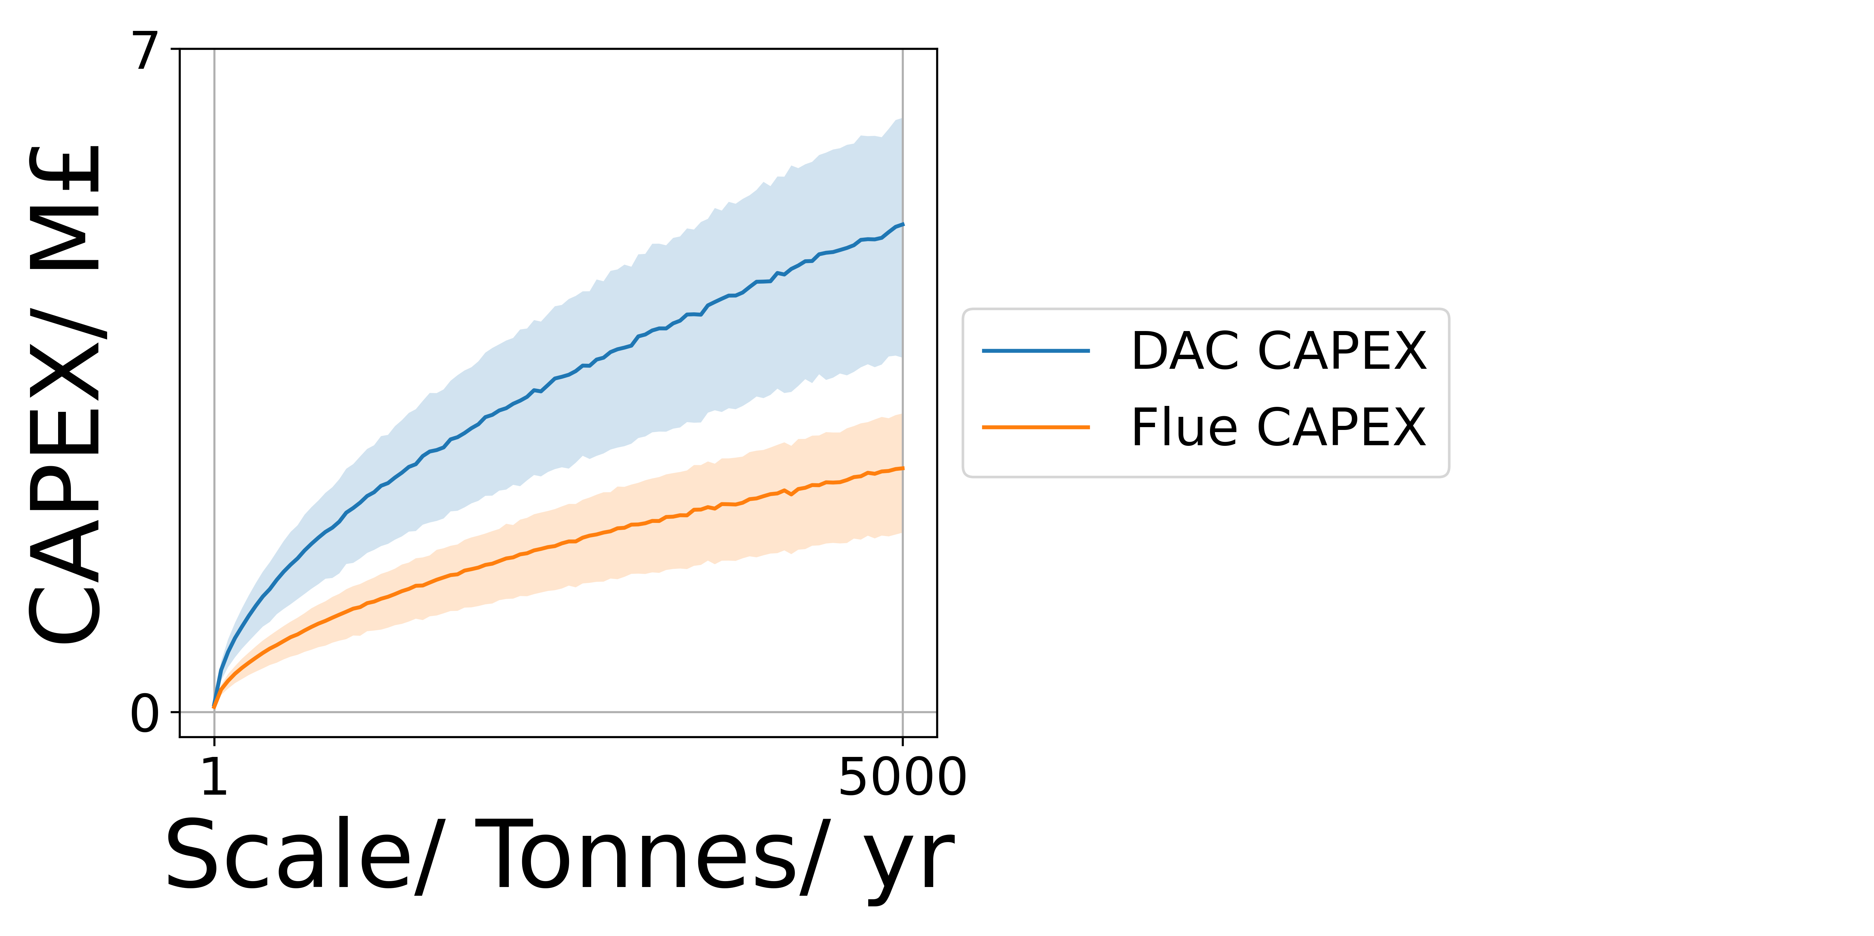 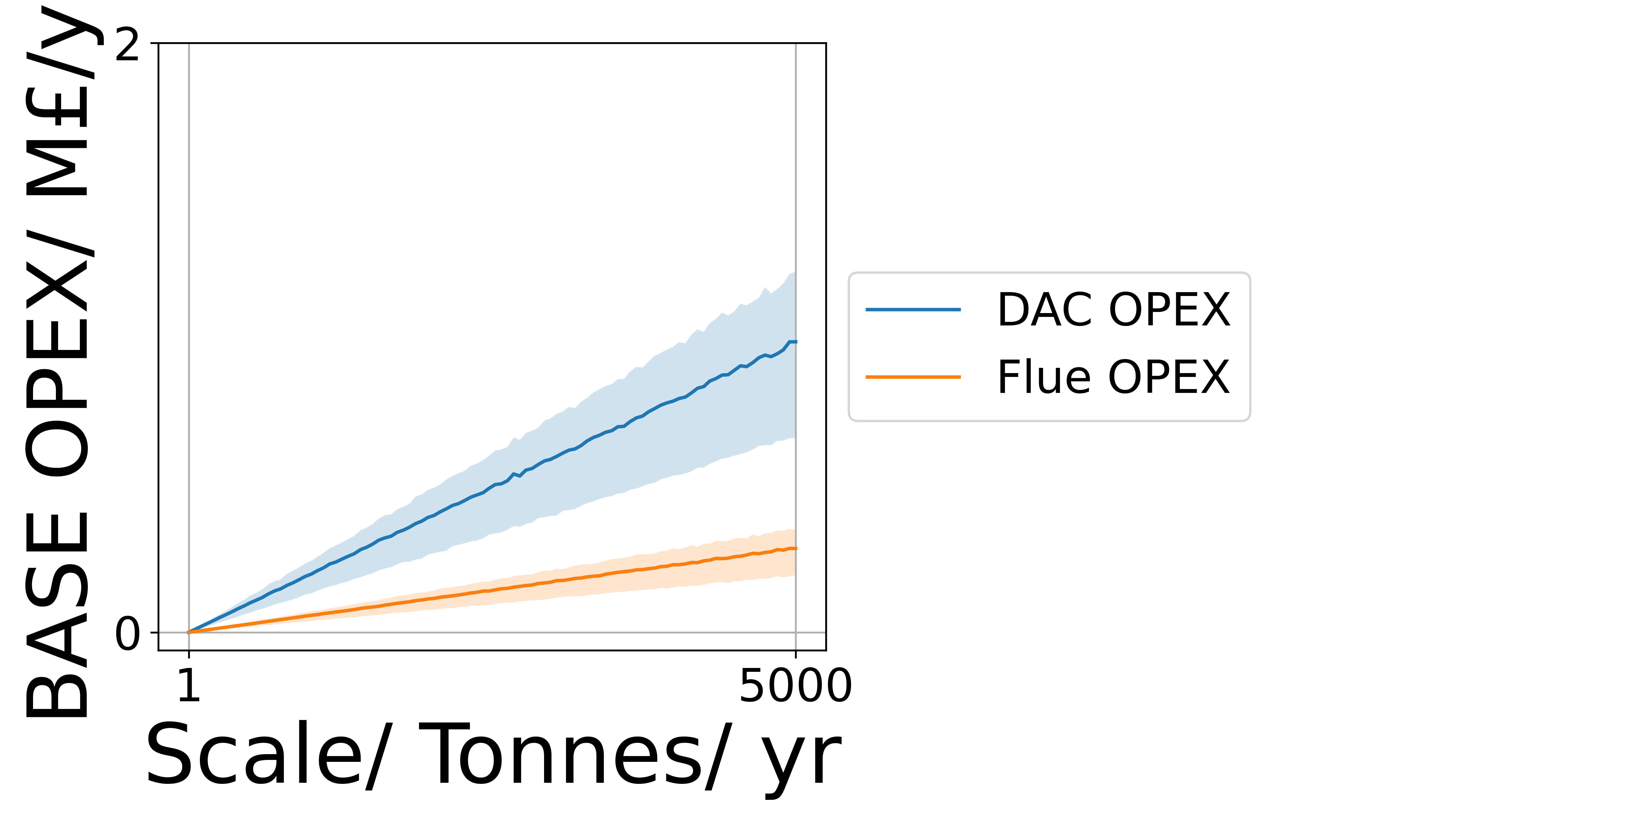

**Figure S1.1:** The effect of plant scale on Carbon Capture Subsystem CAPEX (a) and OPEX (b) **.** DAC (blue) and Flue (Orange). A reference condition of a 1 kilotonne scale, 90% capture efficiency, 20% 2nd Law efficiency and a required purity of 95% were used, all properties and parameters have an error of 50%.

**a) b)**

 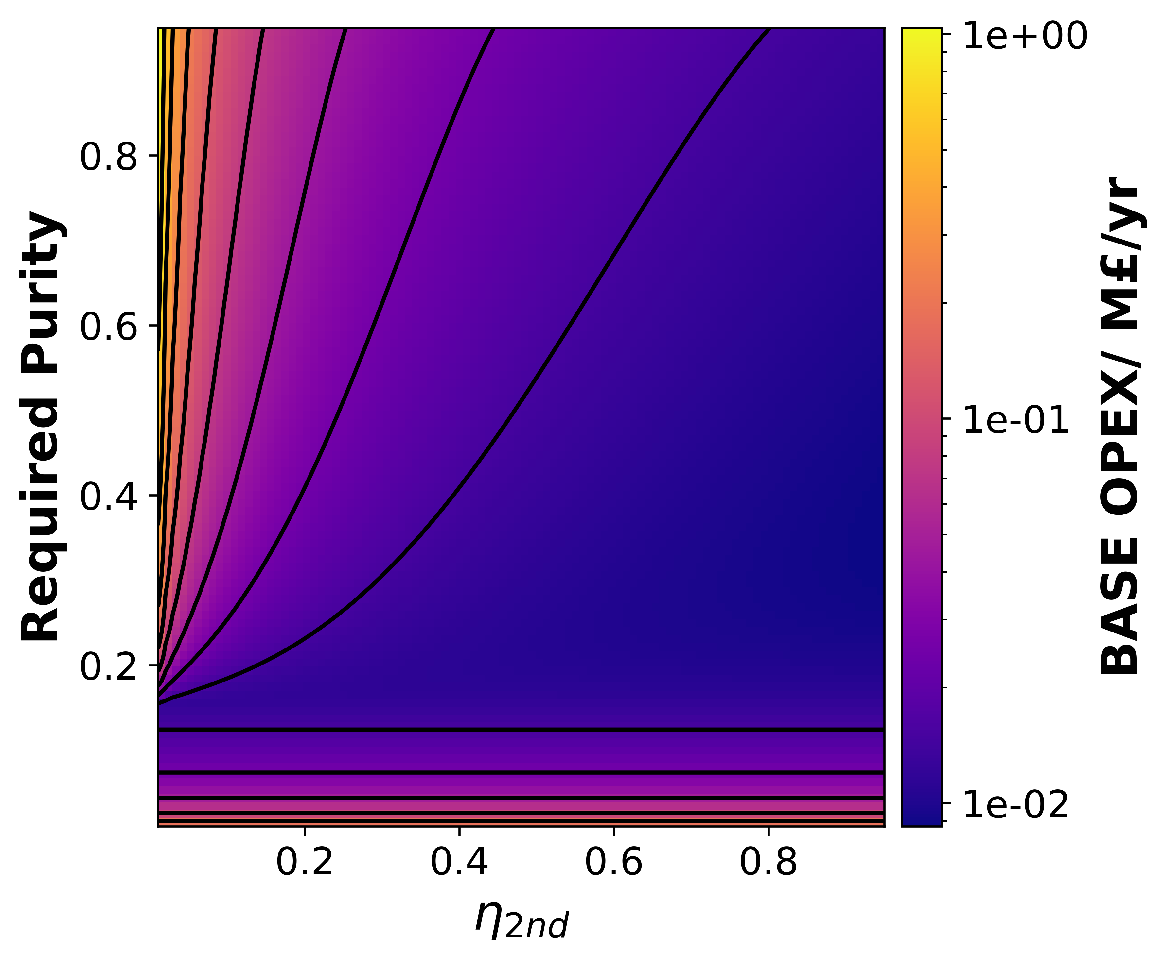

**c) d)**

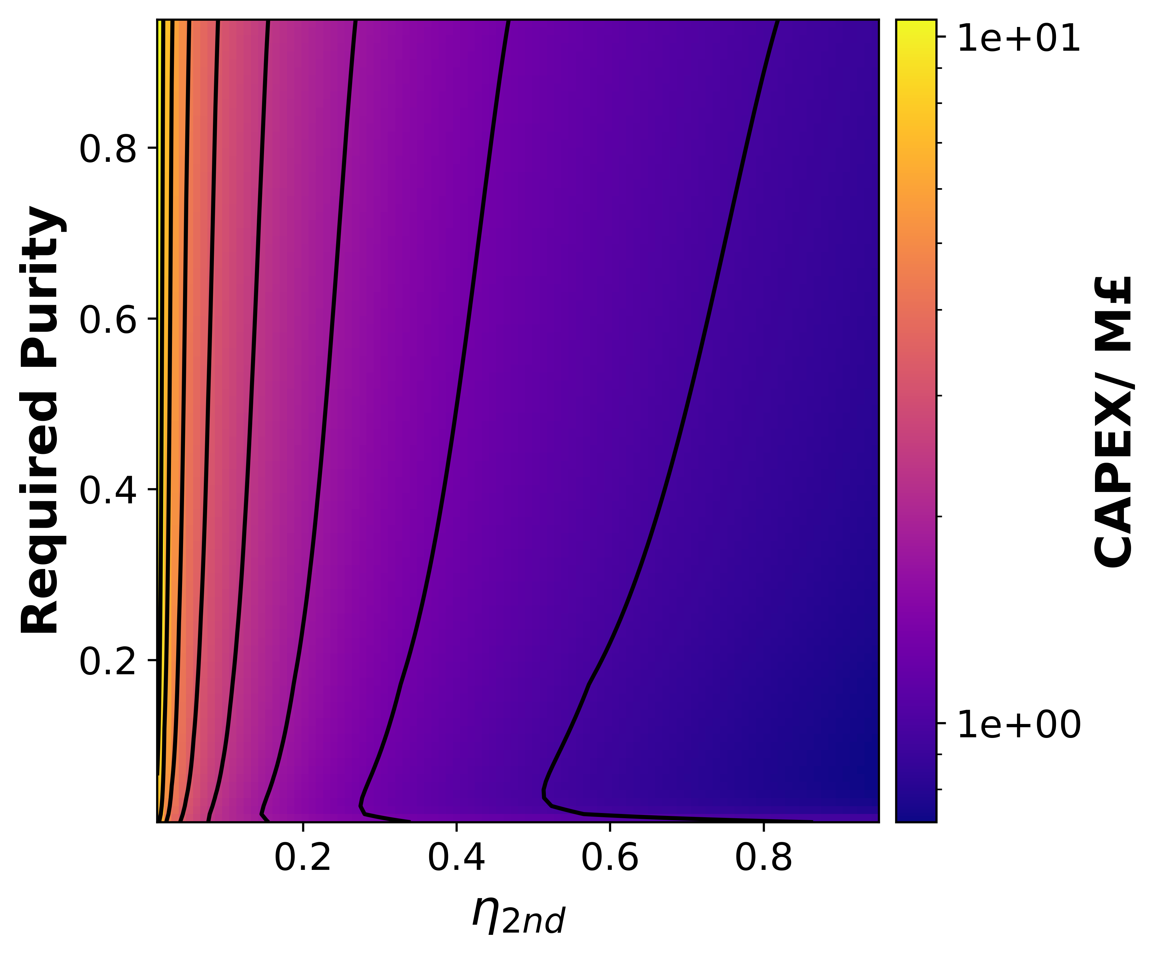 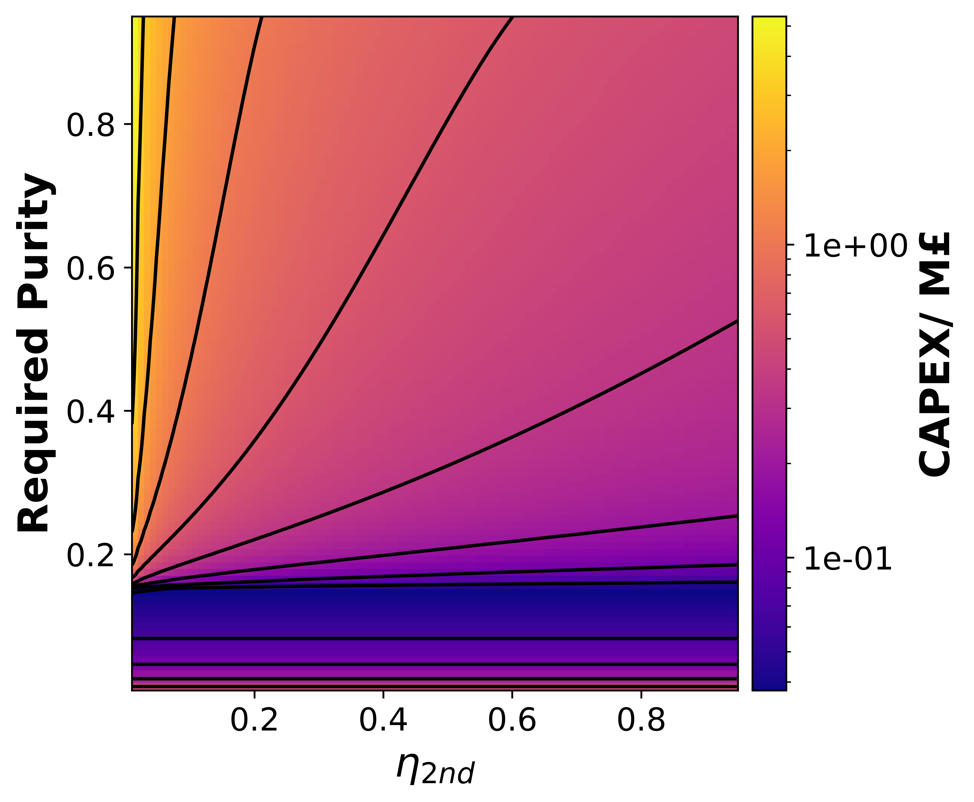

**Figure S1.2:** Colormaps to show the efect of Required Purity and 2nd Law efficiencey on OPEX (a,b) and CAPEX (c,d) for the Carbon capture susbsystem. Plots (a,c) are with DAC while (b,d) are with Flue gas carbon capture. A reference condition of a 1 kilotonne scale, 90% capture efficiency, 20% 2nd Law efficiency and a required purity of 95% were used, all properties and parameters were modelled deterministically.

1. Separation

**a) b)**

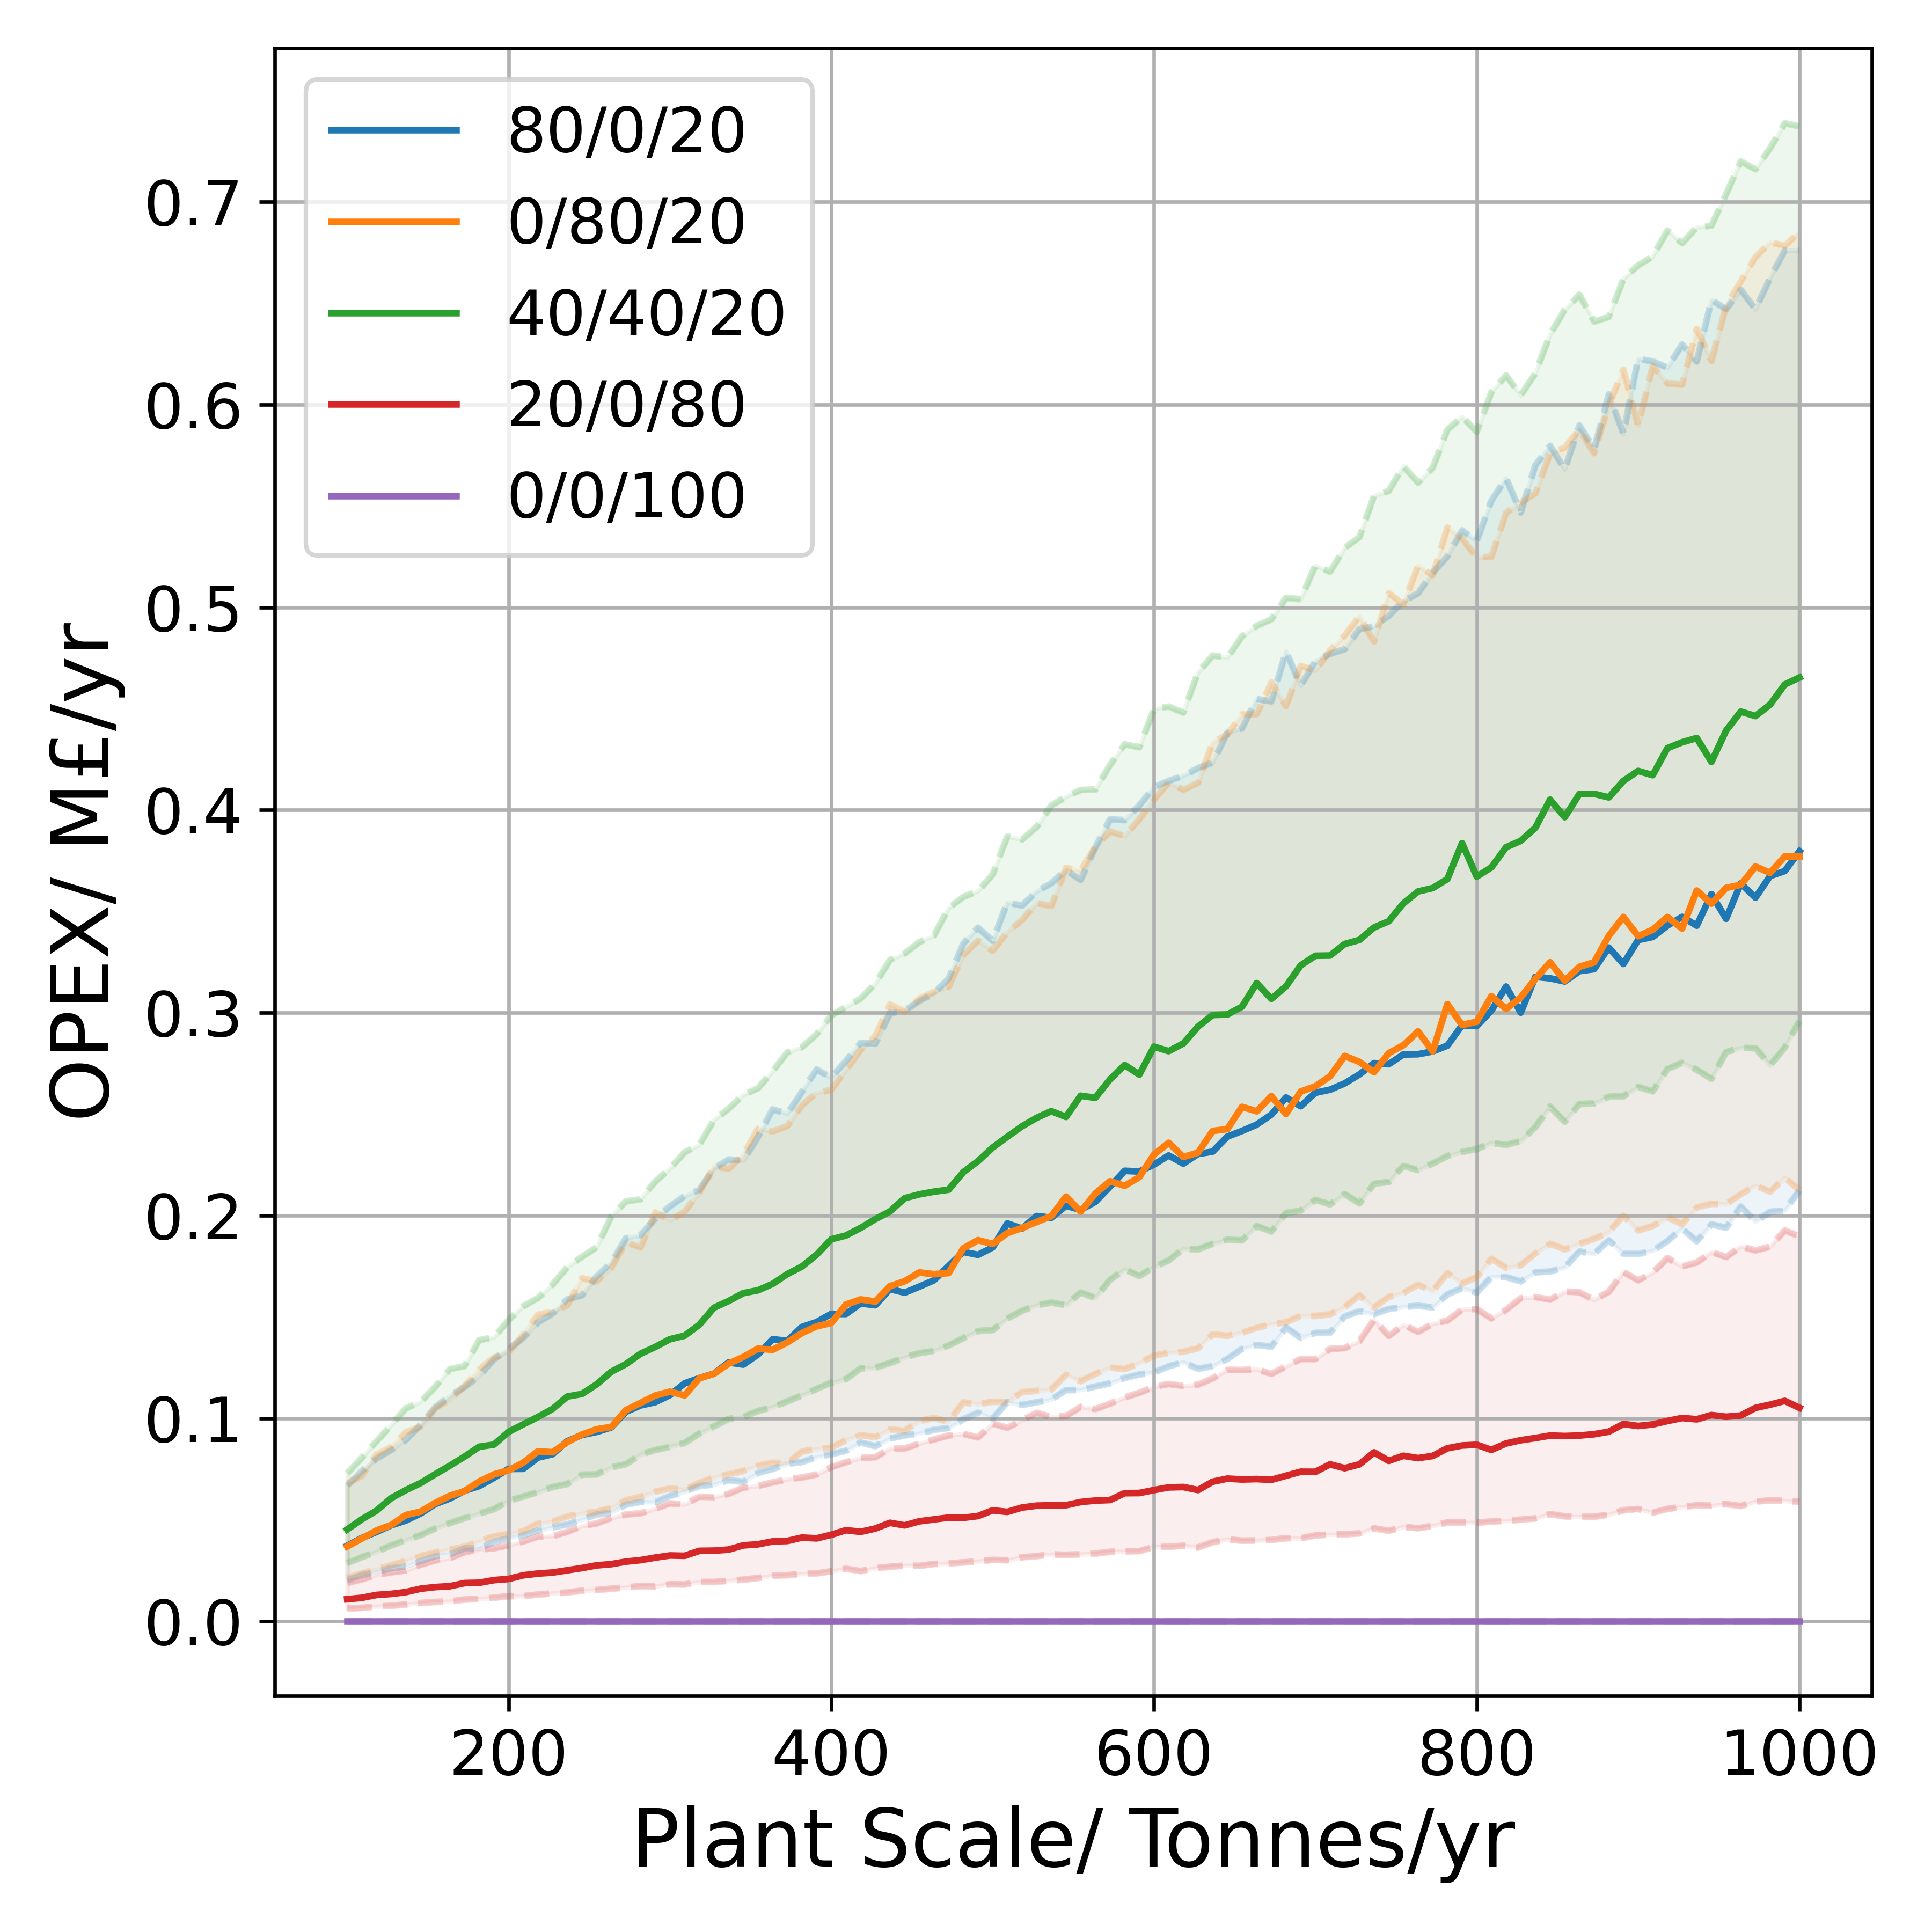 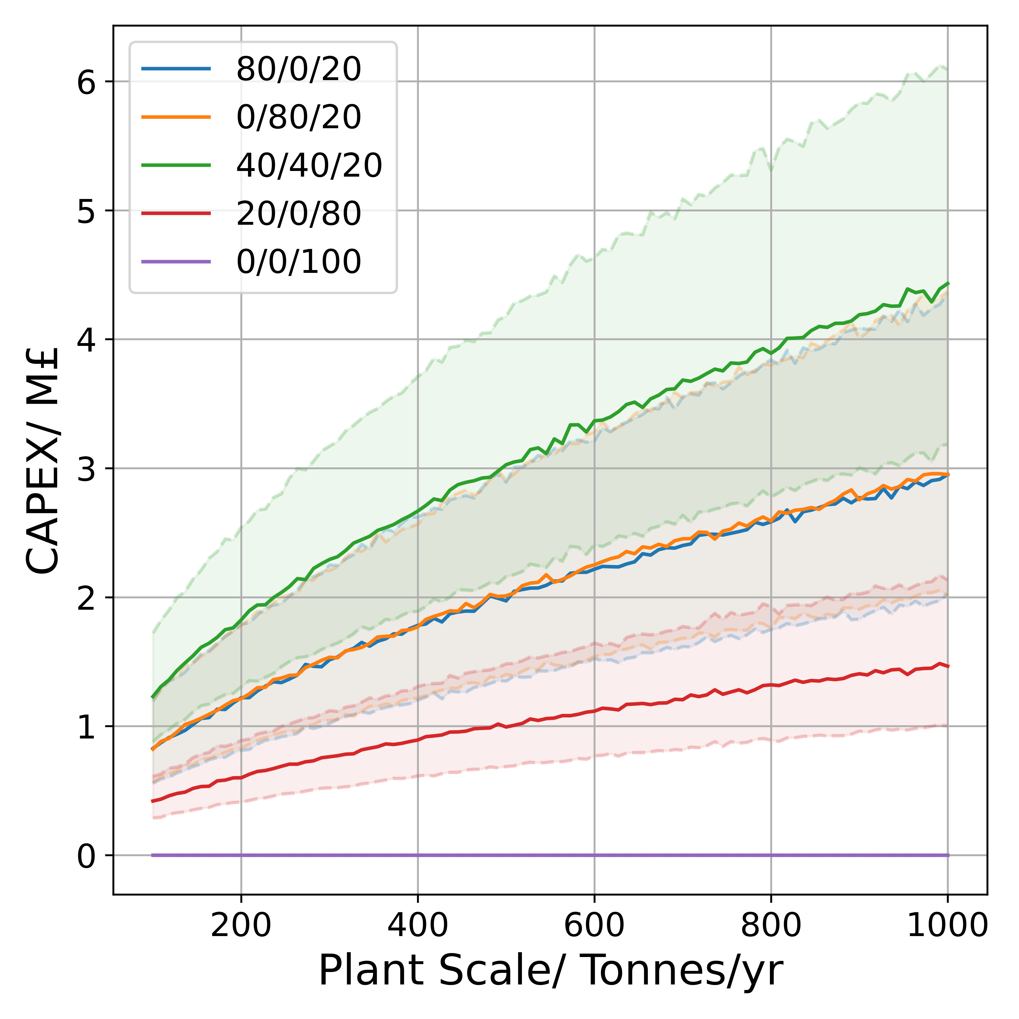

**Figure S1.3:** Plots of Separation subsystem OPEX **(a)**, & CAPEX**(b)** for a range of scales with different product ratios presented given in terms of %Riboflavin/%PHB/%Biomass. All other model parameters are modelled with an uncertainty of 50%.